Put a Brake on Stormwater Runoff from Gas Stations

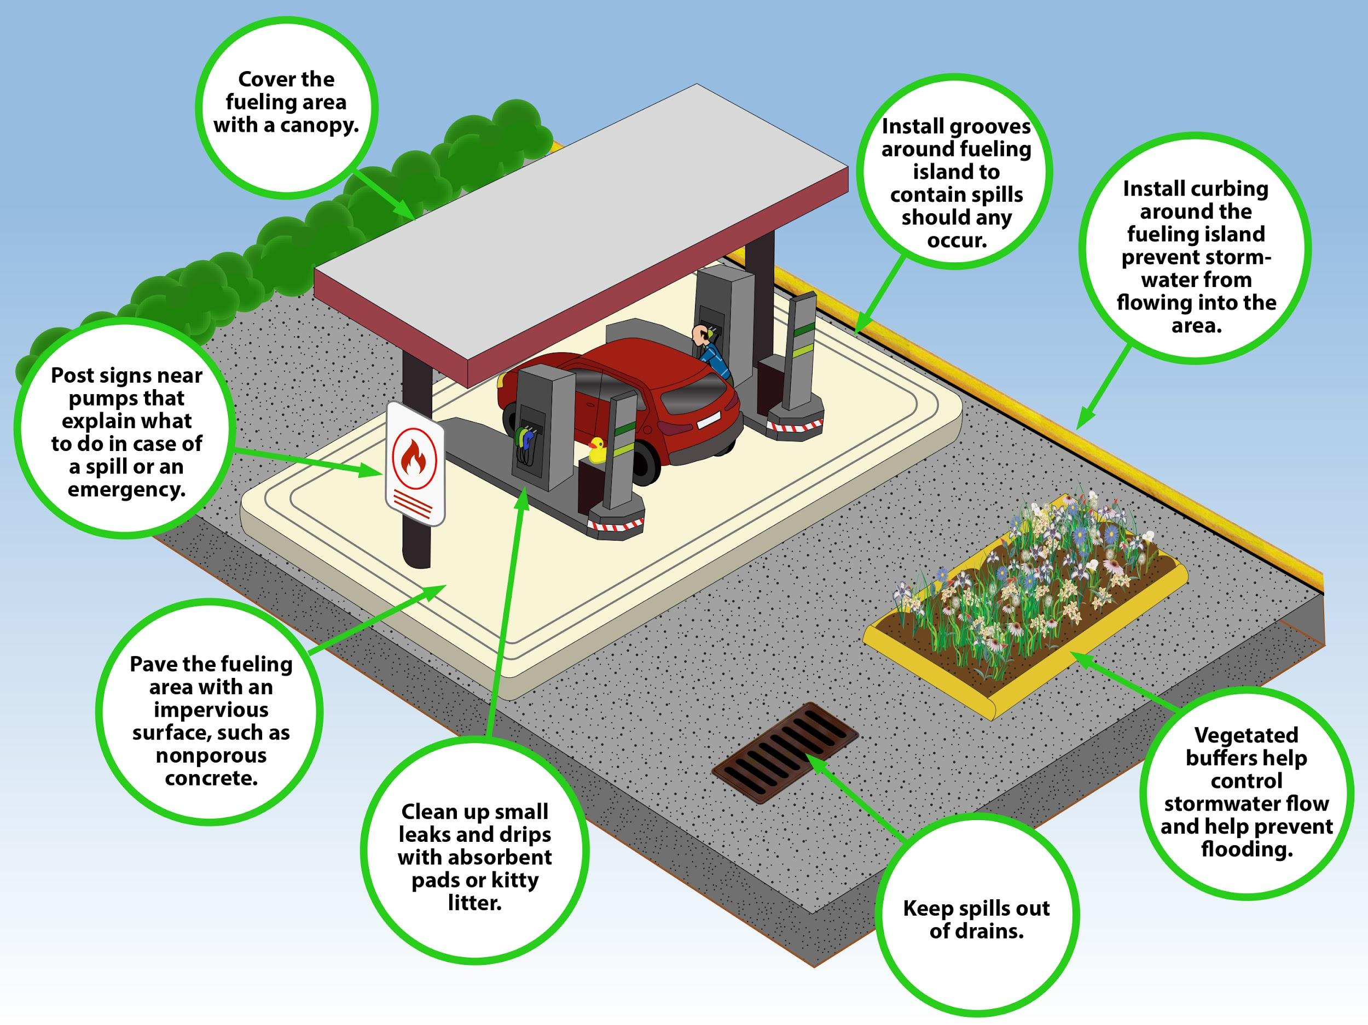
Maintenance is important for the optimal performance of all these practices.

