Neponset Stormwater Partnership
Educational Advertisement Campaign Report

On behalf of the members of the Neponset Stormwater Partnership, Think Blue Massachusetts ran an educational advertising campaign from May 31 to June 25th, 2018. The “Fowl Water” advertisement helps viewers visualize stormwater pollution from motor oil, pet waste, and trash become stormwater pollution.

We selected Facebook sponsored video and YouTube pre-roll advertisements for two primary reasons:

- These channels offer superior “bang for the buck” to cable and broadcast television
- Facebook and YouTube will accept the file formats that were available to us in 2018

This effort helps Partnership members meet their requirements to “document in each annual report the messages for each audience; the method of distribution; the measures/methods used to assess the effectiveness of the messages, and the method/measures used to assess the overall effectiveness of the education program.”
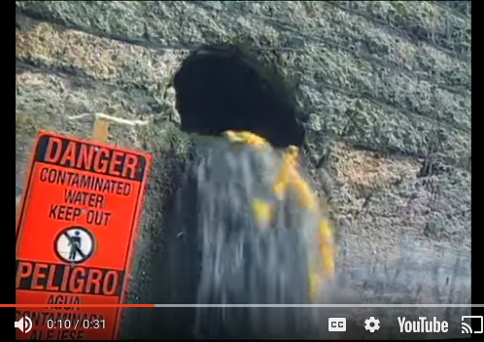

View the ad at http://bit.ly/-tbm-fowl-water

Message Targeting
Think Blue Massachusetts targeted the advertisements to residents of the following municipalities:
- Canton
- Dedham
- Foxborough
- Medfield
- Milton
- Norwood
- Quincy
- Sharon
- Stoughton
- Westwood

Google & Facebook estimate they can reach approximately 360,000 people in these areas. Residency is determined using a combination of account registration information and IP addresses.

Campaign Performance

Here are some highlights about how the campaign performed in this region:

Facebook

# of People Reached | Average # of Impressions Per Person | Total # of Impressions | Watched 10+ seconds | Visited www.ThinkBlueMassachusetts.org
106,752 | 6.01 | 641,193 | 16,682 | 551

Google

# of People Reached | Average # of Impressions Per Person | Total # of Impressions | Watched 10+ seconds | Visited www.ThinkBlueMassachusetts.org
96,873 | 2.2 | 222,518 | 78,516 | 315

