Lawn and Garden Tips to Help Curb Stormwater Pollution

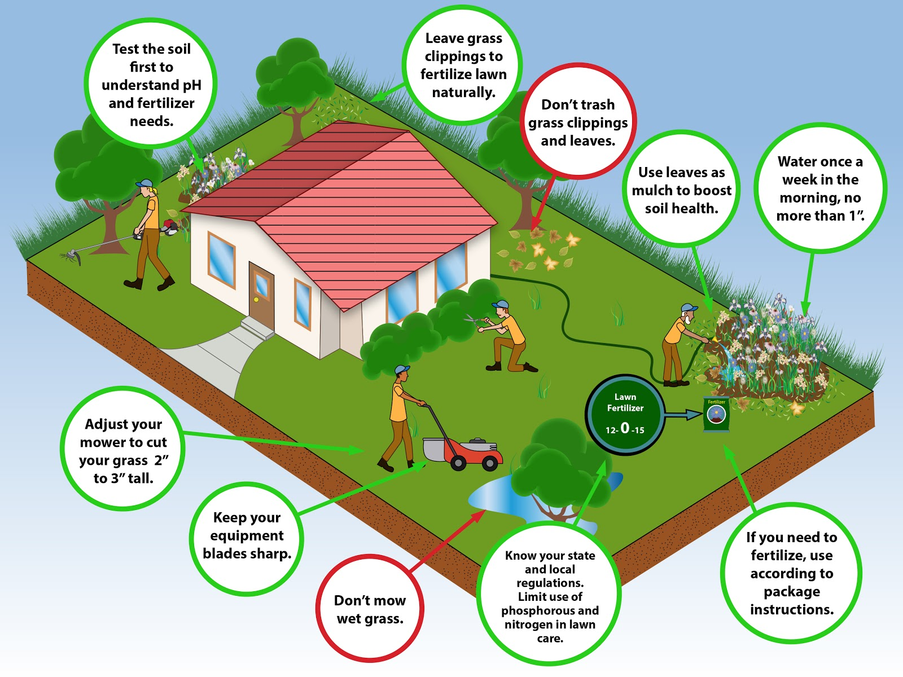

Under Massachusetts law, only apply fertilizer with phosphorus if:
- A soil test shows that phosphorus is needed; or
- During the first growing season for a newly established lawn.

Contact the UMass Cooperative Extension Soil Nutrient Testing Laboratory to learn how to conduct a routine soil test: https://ag.umass.edu/services/soil-plant-nutrient-testing-laboratory/ordering-information-forms

